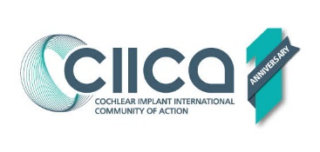
Celebrating CIICA’s First ANNIVERSARY: International CI day
25 February 2022
International Cochlear Implant (CI) Day, 25 February, is also the first anniversary of CIICA – the CI International Community of Action. In one year, CIICA's network has grown to 75 organisations, and 350 individuals from 48 countries across the globe, united in the goal of increasing access to cochlear implantation and lifelong services for all those with hearing loss who can benefit. Hearing loss has a huge, unrecognised impact on both adults and children when unaddressed.
The World Report on Hearing from WHO concluded that “ Cochlear Implant is one of the most successful neural prostheses developed to date”, changing lives and opportunities. In spite of this, currently only 1 in 20 of those globally who could benefit receive this life-changing technology for children and adults who are deaf or have a hearing loss. This gap in provision results in a massive personal and public health issue and additional costs in dealing with the consequences of unaddressed hearing loss despite the proven benefits of CI.
CIICA’s global community of CI advocacy groups provides opportunities to share resources, tools and activities and strengthen the user and family voice to increase access to CI's. CIICA LIVE events and CIICA Conversations provide opportunities for our network to share their advocacy challenges and successes, and to inspire each other to action.
The pandemic has made us all aware of the huge value of communication in our lives and for those with hearing loss the technology of CI can be key to communication and connection with other people.
Visit www.ciicanet.org to see our global activities and hear our shared voice.
Any queries to info@ciicanet.org

