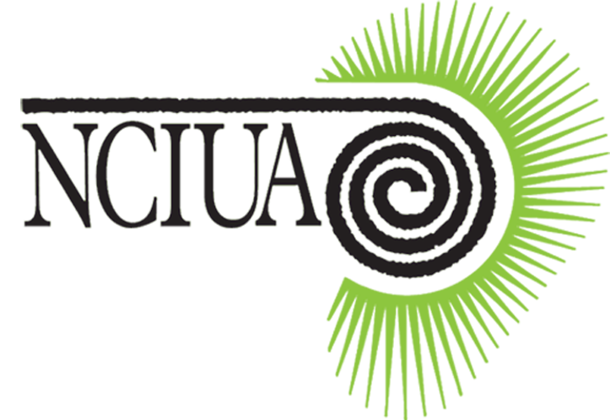
CARDIFF TECHNOLOGY DAY
Saturday 2 November 2019
Clayton Hotel Cardiff
St Mary Street
Cardiff CF10 1GD

The Technology Day 2019 will take place on 2nd November at the Clayton Hotel Cardiff starting at 11.00 am.
This will be an opportunity to find out about the latest cochlear implant developments and ask the manufacturers about how to make the most out of your implant and any accessories you use during workshop sessions.
Numbers are limited to 40. Members and their guests are welcome. Non-members are invited but priority will be given to members and those non-members who are cochlear implant users.
Clayton hotel is situated just 2 minutes away from Cardiff Central Railway Station. Parking is available at the station car park or at the NCP Westgate Street car park about 6 minutes walk from the hotel.
Overnight accommodation is available for 1 & 2 November at £89.00 per night with breakfast single occupancy or £99.00 per night with breakfast based on 2 persons sharing a twin/double room. If you require accommodation please contact Clayton Hotels directly quoting block ID 729700 by emailing res.cardiff@claytonhotels.com or phoning 029 20668866 before 25/10/2019.

Cardiff Technology Day, 2 November 2019
Please reserve ……. places (at £15 per head) for me at a total cost of £……
Please print off this section, enclose your cheque for £……, payable to NCIUA
and post to NCIUA, 11 Hamilton Close, Bicester, OX26 2HX

Places are limited to 40 and will allocated on a first come basis.
Reservations will be acknowledged by email to save costs

Name: ……………………………………………………………………………..

Address: …………………………………………………………………………..

………………………………………………………………………………

……………………………………………………………………………..

Email: ………………………………………………………………………………………

Manufacturer of your implant: Advanced Bionics / Cochlear / MED EL / Oticon; Please circle
(This information is very important to determine the size of Workshop Session Groups)

