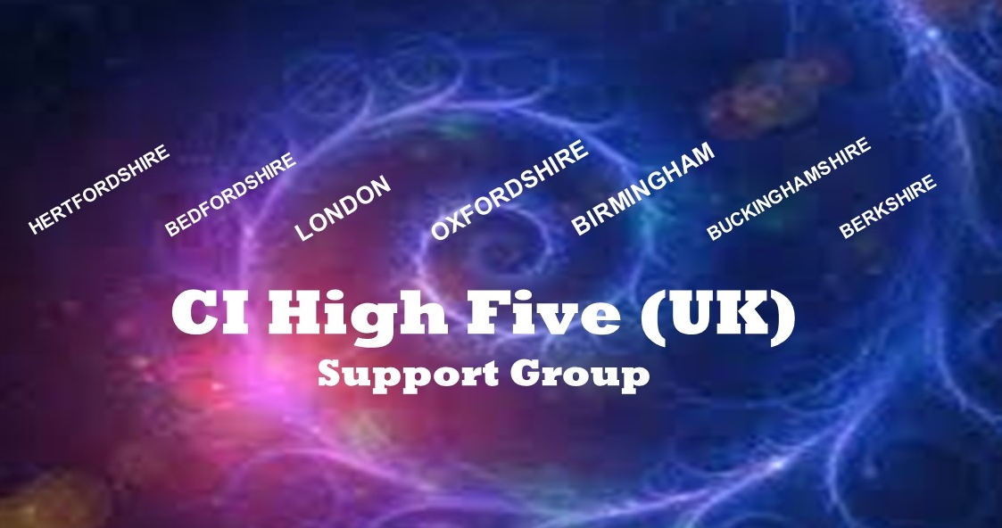
Hi there, are you interested in joining the CI High Five (UK) support group?
This voluntary group is setup to support cochlear implant (CI) candidates and users across Oxfordshire, Hertfordshire, Bedfordshire, Buckinghamshire, Berkshire, Birmingham and London. The group has grown rapidly since January 2017 and currently we have more than 300 members and growing by the day!
Chat to others online – A SECURE closed Facebook group (online) exists for people who are at the start or progressing on their CI journey along with those who have been implanted. You may be a new candidate and have no idea where to turn to for support? You can be assured this group is here to help! There is a lot of experience readily available to those who need it or you may just want to chat with others? The group is inspiring and friendly. It’s amazing what you can learn and how much support is available to you. Queries, concerns or just general chit-chat. We’re here to help! Join today!
Search for: CI High Five (UK)

Chat to others at social events - In 2017 the group held CI social events in Aylesbury, High Wycombe, Milton Keynes, Reading, Oxford, London. For 2018 we are focussing on five main locations, namely; OXFORD, LONDON, READING, BIRMINGHAM AND ST. ALBANS. The events are very successful, well attended and people leave feeling inspired by others.

An informal and friendly environment is the norm with people who understand about hearing loss and the challenges it presents because we have been there ourselves and have first-hand experience! No need to worry or be stressed about struggling to hear as the venues will have no background noise (music/TV) which will aid better hearing for those who may be at the start of their journey (wearing hearing aids) or new to the CI hearing world! People have found much inspiration from attending. Talking to others very often allays fears and concerns associated with being profoundly deaf and cochlear implantation. Whatever stage of the process, people will understand and be supportive for sure.

Partners, parents of CI children and friends of CI users or candidates are also invited as well as Hearing Dogs. We welcome people with a wide variety of backgrounds too – whether you are born deaf, late deafened, sign, don’t sign or a bit of both.

We have a full schedule of CI social events (one every month) for 2018 so make sure you hold the dates in your diary and make contact so that we can include you into our distribution group. We shall send you details of future events.

Check out our public Facebook page for up and coming social events.
Search for: CI UK Social Events
2018 Event Dates
20th January | 14th April | 1st July | 15th September | 8th December
10th February | 19th May | 28th July | 20th October
17th March | 2nd June | 25th August | 17th November

Alternatively send us an email and you will be added to our email distribution list for future events.

Email Address: CIHighFive@gmail.com

And finally…. If you are wondering who the organisers are. Yasir, Anne and Carol are profoundly deaf individuals who have been through the CI journey and implanted. Our lives have completely changed as a result of the implant and we now enjoy being part of the hearing world. Helping others is a small token of appreciation for the fabulous gift of hearing we have been given. YOU could be the same! Join us now. You won’t regret it…….

E-Mail: CIHIGHFIVE@GMAIL.COM

Facebook (Chat & Discussion): CI HIGH FIVE (UK)
Facebook (Social Events): CI UK SOCIAL EVENTS
Twitter (News & Messaging): @CIHIGHFIVE

The group is friendly and supportive and for all brands of cochlear implants, Advanced Bionics, Cochlear and Med-El
